19.Massive MIMO Capacity and Channel Simulation
Objective:
- To simulate a Massive MIMO system (e.g., 64×16) for analyzing high-dimensional antenna array behavior.
- To evaluate spectral efficiency, spatial multiplexing gain, and BER under Rayleigh fading for assessing link reliability and throughput.
- To compare SU-MIMO and MU-MIMO performance to determine capacity gains and user fairness in multiuser scenarios.

Theory:

1. Massive MIMO Principle:Massive MIMO uses many antennas (e.g., 64) to provide high spatial diversity and beamforming gain, improving link reliability and capacity.

2. SU-MIMO vs MU-MIMO:SU-MIMO sends multiple streams to one user for high data rate, while MU-MIMO serves many users at once, increasing total throughput and improving user fairness.

3. Spatial Multiplexing & Capacity:Multiple antennas create parallel data streams, increasing spectral efficiency and channel capacity depending on the channel rank.

4. Rayleigh Fading Impact:Rayleigh fading causes random signal variations; Massive MIMO mitigates this through diversity and channel hardening.

5. Precoding & Interference Control:Precoding methods like MRT and ZF direct energy to intended users and suppress interference, improving SINR and multiuser performance.

Procedure:
- Set simulation parameters including number of BS antennas (e.g., 64), number of users (e.g., 16), modulation order, channel model, and SNR range.
- Generate random data bits for each user according to the number of spatial streams and modulation scheme.
- Map the generated bits to QPSK, 16-QAM, or 64-QAM symbols based on SNR.
- Create a Rayleigh fading Massive MIMO channel matrix with appropriate dimensions (e.g., 64×16).
- Apply precoding methods such as MRT or ZF to form beams and manage multiuser interference.
- Transmit the precoded symbols through the MIMO channel and add AWGN noise.
- Perform receiver detection (ZF/MMSE) to retrieve user symbols and convert them back to bits.
- Calculate performance metrics including spectral efficiency, multiplexing gain, BER, and total capacity.
- Simulate SU-MIMO and MU-MIMO separately and compare user throughput, SINR, and fairness.
- Plot performance graphs such as capacity vs SNR and BER vs SNR for both SU-MIMO and MU-MIMO.
- Display final results showing per-user rate, total system throughput, and capacity improvement due to Massive MIMO.

CODE:
% massive_mimo_sim.m
% Massive MIMO capacity and channel simulation (64 x 16)
% Compares SU-MIMO (64 x 16 single user) and MU-MIMO (64 x 16 users single-antenna)
% Calculates spectral efficiency (sum-rate) and BER (QPSK) under Rayleigh fading
% Linear MU precoders: MRT, ZF, MMSE; SU uses SVD-based spatial multiplexing (equal power)
clearvars; close all; clc;
rng(0); % reproducible
%% Simulation parameters
Nt = 64; % number of BS transmit antennas
K = 16; % number of single-antenna users (for MU-MIMO)
Nr_SU = 16; % number of antennas at single SU (for SU-MIMO)
numRealizations = 500; % channel realizations for capacity averaging
SNRdB = -10:5:20; % SNR range in dB (total transmit power = 1)
SNRlin = 10.^(SNRdB/10);
% BER simulation parameters
numSymbolsBER = 2000; % per SNR (reduce/increase as desired)
maxBERrealizations = 200; % limit realizations for BER loop to keep runtime reasonable
% modulation: QPSK
M = 4;
qpskSymbols = [1+1j, 1-1j, -1+1j, -1-1j] / sqrt(2); % unit energy
%% Pre-allocate results
rates_SU = zeros(length(SNRdB),1);
rates_MRT = zeros(length(SNRdB),1);
rates_ZF = zeros(length(SNRdB),1);
rates_MMSE= zeros(length(SNRdB),1);
BER_MRT = zeros(length(SNRdB),1);
BER_ZF = zeros(length(SNRdB),1);
BER_MMSE= zeros(length(SNRdB),1);
BER_SU = zeros(length(SNRdB),1);
%% --- CAPACITY / SUM-RATE Monte Carlo loop ---
for rr = 1:numRealizations
% MU channel: H (K x Nt) each row is user channel (1 x Nt)
H_mu = (randn(K,Nt) + 1j*randn(K,Nt)) / sqrt(2); % Rayleigh CN(0,1)
% SU channel: Hsu (Nr x Nt) single user MIMO
H_su = (randn(Nr_SU,Nt) + 1j*randn(Nr_SU,Nt)) / sqrt(2);
% Precompute SVD for SU
[U_su, S_su, V_su] = svd(H_su); % H_su = U * S * V'
singularValsSq = diag(S_su).^2; % eigenvalues of H*H'
Ns = min(Nr_SU,Nt);
for si = 1:length(SNRdB)
sigma2 = 1 / SNRlin(si); % noise variance if total transmit power = 1

%% SU-MIMO capacity (equal power per stream)
perStreamPower = 1 / Ns;
rate_streams = sum( log2(1 + (perStreamPower * singularValsSq(1:Ns)) / sigma2 ) );
rates_SU(si) = rates_SU(si) + real(rate_streams);
%% MU-MIMO: compute precoders based on H_mu
% MRT (Maximum Ratio Transmission)
W_mrt = H_mu'; % Nt x K
% Normalize total transmit power to 1: divide by Frobenius norm
W_mrt = W_mrt / sqrt(trace(W_mrt * W_mrt'));
% ZF precoder: W_zf = H' * inv(H*H') (pseudo-inverse)
% Use regular pseudoinverse for numerical stability
W_zf = H_mu' * pinv(H_mu * H_mu'); % Nt x K
W_zf = W_zf / sqrt(trace(W_zf * W_zf'));
% MMSE precoder: W_mmse = H' * inv(H*H' + (K/SNR)*I)
mmseTerm = H_mu * H_mu' + (K * sigma2) * eye(K);
W_mmse = H_mu' * (mmseTerm \ eye(K)); % Nt x K
W_mmse = W_mmse / sqrt(trace(W_mmse * W_mmse'));
% Compute per-user SINR and rate for each precoder
% Precompute product matrices to speed up
% For each user i:
% y_i = h_i * W * s + n ; SINR_i = |h_i w_i|^2 / (sum_{j != i} |h_i w_j|^2 + sigma2)
for precoderType = 1:3
if precoderType==1, W = W_mrt;
elseif precoderType==2, W = W_zf;
else, W = W_mmse;
end
% compute effective channel gains matrix G = H * W (K x K)
G = H_mu * W; % element (i,j) = h_i * w_j
% signal power per-user: |G_ii|^2 ; interference: sum_{j != i} |G_ij|^2
signalPow = abs(diag(G)).^2;
totalPow = sum(abs(G).^2,2);
interfPow = totalPow - signalPow;
SINR = signalPow ./ (interfPow + sigma2);
sumRate = sum( log2(1 + SINR) );
if precoderType==1
rates_MRT(si) = rates_MRT(si) + real(sumRate);
elseif precoderType==2
rates_ZF(si) = rates_ZF(si) + real(sumRate);
else
rates_MMSE(si)= rates_MMSE(si)+ real(sumRate);
end
% Average over realizations
rates_SU = rates_SU / numRealizations;
rates_MRT = rates_MRT / numRealizations;
rates_ZF = rates_ZF / numRealizations;
rates_MMSE= rates_MMSE/ numRealizations;
%% --- BER SIMULATION (QPSK) ---
% We'll simulate BER for a limited number of channel realizations to keep runtime reasonable.
berRealizations = min(maxBERrealizations, numRealizations);
for rr = 1:berRealizations
H_mu = (randn(K,Nt) + 1j*randn(K,Nt)) / sqrt(2);
H_su = (randn(Nr_SU,Nt) + 1j*randn(Nr_SU,Nt)) / sqrt(2);
[U_su, S_su, V_su] = svd(H_su);
Ns = min(Nr_SU,Nt);
% generate QPSK symbols (K streams concurrently for MU; Ns streams for SU)
bitsPerSym = log2(M);
% symbols per batch
s_mu_idx = randi([1 M], K, numSymbolsBER); % indices
s_mu = qpskSymbols(s_mu_idx);
s_su_idx = randi([1 M], Ns, numSymbolsBER);
s_su = qpskSymbols(s_su_idx);
for si = 1:length(SNRdB)
sigma2 = 1 / SNRlin(si);
% --- MU Precoding ---
% recompute precoders for current H_mu
W_mrt = H_mu'; W_mrt = W_mrt / sqrt(trace(W_mrt * W_mrt'));
W_zf = H_mu' * pinv(H_mu * H_mu'); W_zf = W_zf / sqrt(trace(W_zf * W_zf'));
mmseTerm = H_mu * H_mu' + (K * sigma2) * eye(K);
W_mmse = H_mu' * (mmseTerm \ eye(K)); W_mmse = W_mmse / sqrt(trace(W_mmse * W_mmse'));
% transmit and receive for each precoder
% Add AWGN with variance sigma2 per complex dimension
% y = H * W * s + n
% detection: each user equalizes by scalar g_i = h_i w_i (complex) then decide nearest QPSK
% prepare AWGN
noise = sqrt(sigma2/2) * (randn(K,numSymbolsBER) + 1j*randn(K,numSymbolsBER));
% MRT
x = W_mrt * s_mu; % Nt x numSymbols
y = H_mu * x + noise; % K x numSymbols
Gdiag = diag(H_mu * W_mrt); % Kx1
r = bsxfun(@rdivide, y, (Gdiag + 1e-12)); % equalize per-user
% decision: nearest constellation point
% map to indices
% create function inline for mapping
detected_idx = zeros(K, numSymbolsBER);
for k = 1:K
% distance to each constellation point
% use vectorized distance
d = abs(bsxfun(@minus, r(k,:), qpskSymbols.')).^2; % M x symbols
[~, idx] = min(d, [], 1);
detected_idx(k,:) = idx;
end
BER_batch = sum(detected_idx(:) ~= s_mu_idx(:)) / (K * numSymbolsBER);
BER_MRT(si) = BER_MRT(si) + BER_batch;
% ZF
x = W_zf * s_mu;
y = H_mu * x + noise;
Gdiag = diag(H_mu * W_zf);
r = bsxfun(@rdivide, y, (Gdiag + 1e-12));
detected_idx = zeros(K, numSymbolsBER);
for k = 1:K
d = abs(bsxfun(@minus, r(k,:), qpskSymbols.')).^2;
[~, idx] = min(d, [], 1);
detected_idx(k,:) = idx;
end
BER_batch = sum(detected_idx(:) ~= s_mu_idx(:)) / (K * numSymbolsBER);
BER_ZF(si) = BER_ZF(si) + BER_batch;
% MMSE
x = W_mmse * s_mu;
y = H_mu * x + noise;
Gdiag = diag(H_mu * W_mmse);
r = bsxfun(@rdivide, y, (Gdiag + 1e-12));
detected_idx = zeros(K, numSymbolsBER);
for k = 1:K
d = abs(bsxfun(@minus, r(k,:), qpskSymbols.')).^2;
[~, idx] = min(d, [], 1);
detected_idx(k,:) = idx;
end
BER_batch = sum(detected_idx(:) ~= s_mu_idx(:)) / (K * numSymbolsBER);
BER_MMSE(si) = BER_MMSE(si) + BER_batch;
% --- SU-MIMO BER using SVD parallel streams (equal power) ---
% Precoder is V_su(:,1:Ns), combiner U_su(:,1:Ns)'
Vp = V_su(:,1:Ns); UpH = U_su(:,1:Ns)'; % UpH * H * Vp = Sdiag
% transmit
x_su = Vp * s_su; % Nt x numSymbols
noise_su = sqrt(sigma2/2) * (randn(Nr_SU,numSymbolsBER) + 1j*randn(Nr_SU,numSymbolsBER));
y_su = H_su * x_su + noise_su; % Nr x symbols
r_su = UpH * y_su; % Ns x symbols: parallel channels scaled by singular values
% equalize by singular values
svals = diag(S_su(1:Ns,1:Ns));
r_eq = bsxfun(@rdivide, r_su, (svals + 1e-12)); % remove channel gain
% decision
detected_idx = zeros(Ns, numSymbolsBER);
for stream = 1:Ns
d = abs(bsxfun(@minus, r_eq(stream,:), qpskSymbols.')).^2;
[~, idx] = min(d, [], 1);
detected_idx(stream,:) = idx;
end
BER_batch = sum(detected_idx(:) ~= s_su_idx(:)) / (Ns * numSymbolsBER);
BER_SU(si) = BER_SU(si) + BER_batch;
end
end
% average BERs
BER_MRT = BER_MRT / berRealizations;
BER_ZF = BER_ZF / berRealizations;
BER_MMSE= BER_MMSE/ berRealizations;
BER_SU = BER_SU / berRealizations;
%% --- Plots ---
figure;
plot(SNRdB, rates_SU, '-k','LineWidth',1.8); hold on;
plot(SNRdB, rates_MMSE, '-b','LineWidth',1.6);
plot(SNRdB, rates_ZF, '--r','LineWidth',1.6);
plot(SNRdB, rates_MRT, ':m','LineWidth',1.6);
grid on;
xlabel('SNR (dB)'); ylabel('Sum-rate (bits/s/Hz)');
legend('SU-MIMO (64x16, SVD)','MU-MMSE','MU-ZF','MU-MRT','Location','northwest');
title('Massive MIMO: Sum-rate vs SNR (64x16)');
figure;
semilogy(SNRdB, BER_SU, '-k','LineWidth',1.6); hold on;
semilogy(SNRdB, BER_MMSE,'-b','LineWidth',1.4);
semilogy(SNRdB, BER_ZF, '--r','LineWidth',1.4);
semilogy(SNRdB, BER_MRT, ':m','LineWidth',1.4);
grid on;
xlabel('SNR (dB)'); ylabel('BER (log scale)');
legend('SU-MIMO (SVD)','MU-MMSE','MU-ZF','MU-MRT','Location','southwest');
title('Massive MIMO: BER vs SNR (QPSK)');
%% --- Short conclusions (display) ---
fprintf('\n--- Simulation summary (64 x 16) ---\n');
fprintf('SNR(dB) tested: %s\n', mat2str(SNRdB));
fprintf('Avg sum-rate at SNR = %g dB:\n', SNRdB(end));
fprintf(' SU-MIMO (SVD) : %.2f bits/s/Hz\n', rates_SU(end));
fprintf(' MU-MMSE : %.2f bits/s/Hz\n', rates_MMSE(end));
fprintf(' MU-ZF : %.2f bits/s/Hz\n', rates_ZF(end));
fprintf(' MU-MRT : %.2f bits/s/Hz\n', rates_MRT(end));
fprintf('\nSample BER at SNR = %g dB (QPSK):\n', SNRdB(end));
fprintf(' SU-MIMO (SVD) : %.3e\n', BER_SU(end));
fprintf(' MU-MMSE : %.3e\n', BER_MMSE(end));
fprintf(' MU-ZF : %.3e\n', BER_ZF(end));
fprintf(' MU-MRT : %.3e\n', BER_MRT(end));
fprintf('-----------------------------------\n\n');

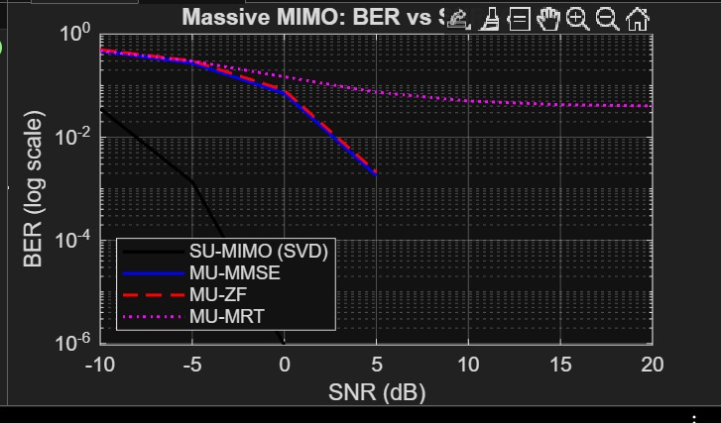
OUTPUT:
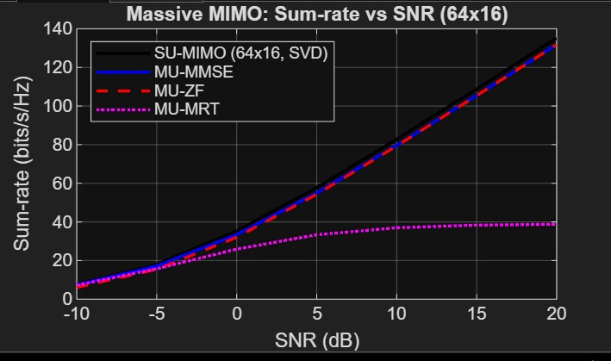
CONSOLE OUTPUT: SNR(dB) tested: [-10 -5 0 5 10 15 20]
Avg sum-rate at SNR = 20 dB:
SU-MIMO (SVD) : 135.21 bits/s/Hz
MU-MMSE : 131.81 bits/s/Hz
MU-ZF : 131.78 bits/s/Hz
MU-MRT : 38.78 bits/s/Hz
Sample BER at SNR = 20 dB (QPSK):
SU-MIMO (SVD) : 0.000e+00
MU-MMSE : 0.000e+00
MU-ZF : 0.000e+00
MU-MRT : 4.037e-02

CONCLUSION:
- Massive MIMO significantly increases capacity and spectral efficiency through spatial multiplexing and beamforming.
- Rayleigh fading effects are greatly reduced due to channel hardening, improving link reliability and lowering BER.
- MU-MIMO outperforms SU-MIMO by serving multiple users simultaneously, enhancing total system throughput and fairness.
- Overall, Massive MIMO provides substantial gains in throughput, interference suppression, and robustness, making it essential for modern 5G and beyond communication systems.

